**Assessing the Prospective Utility of Flat FHIR as a Scalable Standard for Bulk Analysis of Patient-Reported Outcomes**

Parker Bannister

Project Mentor: Dr. Kenneth Mandl, Co-Mentor: Dr. Raheel Sayeed

Department of Biomedical Informatics, Harvard Medical School In Conjunction with The Computational Health Informatics Program at Boston Children’s Hospital

November, 2020

Capstone Manuscript - Format: JAMIA Brief Communication Article

Abstract

HL7 Fast Health Interoperability Resource (FHIR) is a healthcare data standard that is being widely adopted across the healthcare industry. FHIR Bulk Data APIs can be used to pull large sums of FHIR data, enabling the industry to perform bulk analyses. Most electronic health records contain information input by a clinician, however, FHIR yields the opportunity to store structured data provided by patients through validated instruments, called Patient Reported Outcomes. In this analysis, we demonstrate the utility of using FHIR as a scalable standard for structuring patient reported outcomes by converting two National Health and Nutrition Examination Surveys (NHANES) responses to FHIR, and perform bulk analysis using open source tools directly on the resultant NHANES Flat FHIR dataset without requiring cumbersome data transformations to custom formats.

Introduction

Historically, patient data has been stored in paper charts and transferred via fax. This process is both time consuming and error prone. In an attempt to improve this system, the federal government monetarily incentivized providers to transition to Electronic Health Record (EHR) systems in 2009 with the introduction of the HITECH act (1). Initially, commercial EHR systems were built in complex and unique fashions, with different standards across different institutions, making access to patient data burdensome (2). Recent advancements in technologies and healthcare information standards have improved interoperability of health systems to facilitate the seamless electronic flow of patient data. HL7’s Fast Healthcare Interoperability Resources (FHIR) is a new specification of EHR systems that standardizes the format in which patient data are stored and transmitted. Specifically, Flat FHIR (or “Bulk Data API”) is a new specification that enables system wide data pulls from EHR in a standardized format, allowing for rapid bulk analysis and reporting, rather than exporting data one patient at a time (3).

FHIR resources are usually composed of clinical data generated from providers. However, there is an opportunity to, when health systems collect Patient Generated Health Data (PGHD), to also export these data alongside the clinician generated data, in the same “Flat FHIR” format (5). Patient Reported Outcomes (PROs) are essentially surveys, a subset of PGHD that encompass a patient’s perspective of their health status, symptoms, and or quality of life (5, 6). PRO Measures have are valuable adjuncts to provider generated data, however, have not been widely integrated into clinical practice or electronic health records (5, 7). With few accessible information rich PRO datasets, we focused on one well known publicly available de-identified patient survey, the National Health and Nutrition Examination Survey (NHANES) (8). We assess the utility of Flat FHIR (bulk data files), an output of SMART/HL7 Bulk Data API, in research. A synthetic dataset was created by incorporating a PRO dataset generated by transforming NHANES Physical Activity, Mental Health Depression questionnaires and their responses into FHIR and performing bulk analysis using open source tools.

Methods

We generated a PRO dataset by transforming real survey data from the NHANES public repository into FHIR resources. Selecting among the many categories of NHANES questionnaires, we focused on the 2017-2018 Mental Health Depression and Physical Activity with their accompanying patient responses and demographic information.

The data for the two NHANES questionnaires and demographics were available as .XPT files which were converted to .CSV for import. The physical activity questionnaire dataset includes 17 columns, and the mental health depression questionnaire dataset includes 11 columns. Both datasets consist of one column representing respondent ID, and the other columns representing questions about the respondent’s perception of their own physical activity or mental health depression status (9, 10). The demographic dataset includes 47 columns, one being the associated respondent ID, the others representing demographic information such as age in years, race, and socioeconomic status (11). There were 5856 rows in the physical activity dataset and 5533 rows in the mental health depression dataset, each row representing an individual’s response to the survey questions. The NHANES demographic dataset contains 9254 response rows, with rows having matching respondent IDs to both the physical activity and mental health response IDs.

We utilized open source tools to convert the NHANES questionnaire data into FHIR resources. Jupyter Notebook was used as our Python environment, where we imported the SMART Python Client to initialize FHIR resource models, allowing for convenient conversion of the CSV data to FHIR JSON files. Finally, the SMART FHIR R4 Sandbox server was leveraged for debugging and validation of FHIR resources (4, 12).

Results

We first converted the NHANES questionnaires into the proper FHIR resources as per FHIR Questionnaire specification, and then subsequently converted the patients’ responses to the FHIR QuestionnaireResponse specification (13, 14, Figure 1). This was accomplished by creating a Python script to parse the NHANES CSV files, and load the data into FHIR models with the open source SMART Python Client. This resulted in two FHIR Questionnaire files, as well as 5856 physical activity FHIR QuestionnaireResponse files, and 5533 mental health depression FHIR QuestionnaireResponse files. FHIR ValueSets were encoded within the Questionnaire Files to follow FHIR conventions. Identifiers were added to each QuestionnaireResponse FHIR JSON file to associate each QuestionniareResponse to an NHANES survey respondent. The IDs provided in the NHANES datasets were used for these QuestionnaireResponse Identifiers (Table 1, Table 2 ). Due to the coded and de-identified nature of the NHANES data, we were unable to structure the patient demographic information into FHIR Patient resources, and had to pull this information later in the analysis portion and link it to the questionnaire responses.

After the data were loaded into FHIR JSON files, we uploaded the FHIR Questionnaires, and accompanying QuestionnaireResponses to the Boston Children’s Hospital’s Computational Health Informatics Program’s SMART Sandbox / Bulk Data server for validation (4, 12). The ID generated by the SMART Server for the Questionnaires was added to each FHIR QuestionnaireResponse to link each QuestionnaireResponse to its associated Questionnaire. Finally, the respective FHIR resources were bundled in “ndJSON” based Flat FHIR format.

For analysis, we created a python script to transform all elements in Flat FHIR files into a Pandas DataFrame, which included intermediary conversion to python FHIR models. Demographic information was then linked to the patients based on respondent ID. With the patient reported outcomes and accompanying demographic data structured for analysis, we visualized the responses to the various physical activity and mental health depression questionnaires using the python package Seaborn. The data was then stratified by age group and visualized by this demographic stratification. (Github Repo: https://github.com/pbannister123/dbmi-capstone)

|  |  |  |
| --- | --- | --- |
| NHANES Physical Activity Column Name | NHANES Physical Activity Column Description | Converted FHIR Resource Attribute |
| NHANES Identifier | Survey Code | Questionnaire.code.code |
| SEQN | Respondent sequence number | QuestionnaireResponse.identifier.value |
| PAQ605 | Vigorous work activity | Questionnaire.item.linkId |
| PAQ610 | Number of days vigorous work | Questionnaire.item.linkId |
| PAD615 | Minutes vigorous-intensity work | Questionnaire.item.linkId |
| PAQ620 | Moderate work activity | Questionnaire.item.linkId |
| PAQ625 | Number of days moderate work | Questionnaire.item.linkId |
| PAD630 | Minutes moderate-intensity work | Questionnaire.item.linkId |
| PAQ635 | Walk or bicycle | Questionnaire.item.linkId |
| PAQ640 | Number of days walk or bicycle | Questionnaire.item.linkId |
| PAD645 | Minutes walk/bicycle for transportation | Questionnaire.item.linkId |
| PAQ650 | Vigorous recreational activities | Questionnaire.item.linkId |
| PAQ655 | Days vigorous recreational activities | Questionnaire.item.linkId |
| PAD660 | Minutes vigorous recreational activities | Questionnaire.item.linkId |
| PAQ665 | Moderate recreational activities | Questionnaire.item.linkId |
| PAQ670 | Days moderate recreational activities | Questionnaire.item.linkId |
| PAD675 | Minutes moderate recreational activities | Questionnaire.item.linkId |
| PAD680 | Minutes sedentary activity | Questionnaire.item.linkId |

*Table 1- Physical Activity Dataset FHIR Conversions*

|  |  |  |
| --- | --- | --- |
| NHANES Mental Health Depression Column Name | NHANES Mental Health Depression Column Description | Converted FHIR Attribute |
| NHANES Identifier | Survey Code | Questionnaire.code.code |
| SEQN | Respondent sequence number | QuestionnaireResponse.identifier.value |
| DPQ010 | Have little interest in doing things | Questionnaire.item.linkId |
| DPQ020 | Feeling down, depressed, or hopeless | Questionnaire.item.linkId |
| DPQ030 | Trouble sleeping or sleeping too much | Questionnaire.item.linkId |
| DPQ040 | Feeling tired or having little energy | Questionnaire.item.linkId |
| DPQ050 | Poor appetite or overeating | Questionnaire.item.linkId |
| DPQ060 | Feeling bad about yourself | Questionnaire.item.linkId |
| DPQ070 | Trouble concentrating on things | Questionnaire.item.linkId |
| DPQ080 | Moving or speaking slowly or too fast | Questionnaire.item.linkId |
| DPQ090 | Thought you would be better off dead | Questionnaire.item.linkId |
| DPQ100 | Difficulty these problems have caused | Questionnaire.item.linkId |

*Table 2 - Mental Health Depression Dataset FHIR Conversions*

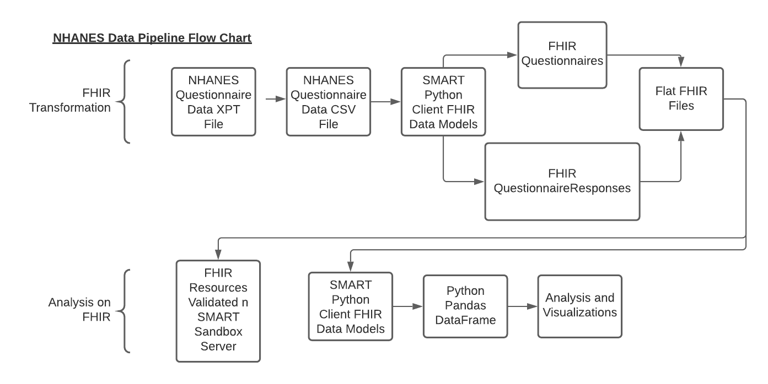

*Figure 1 - NHANES Data Pipeline Flowchart*

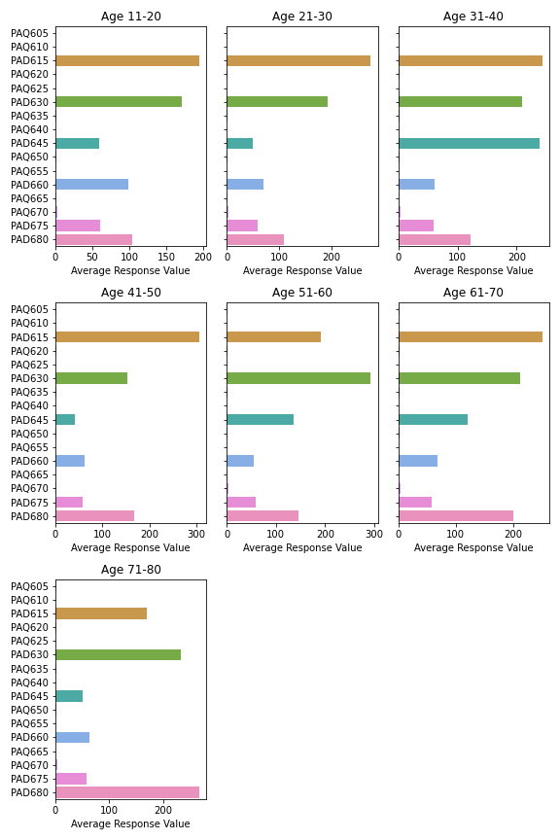

*Figure 2 - Example of Physical Activity Questionnaire Visual Analysis Output: Averaged Responses, Age Stratified*

Discussion

With the recent March 4th, 2020 final rule issued by the ONC as a part of the 21st Century Cures Act, all certified health information technology is required to implement SMART on FHIR and Bulk Data Export/Flat FHIR API into their systems within 36 months of legislation (15, 16). This ruling enables secure access to population level data sets from electronic health records that were previously difficult, if not impossible, to acquire. Now app developers, providers, and researchers can use these tools to accelerate the advancement of population health management and discovery science (16).

Our study assessed the utility of using Flat FHIR and the SMART/HL7 BulkData API as a standard for bulk analysis of patient reported outcomes. We were able to transform the NHANES physical activity and mental health depression surveys into FHIR resources in a standardized manner. Our study also demonstrated that automated bulk analysis of these resources can be accomplished using available open source tools, such as the FHIR Python client, in a rapid and automated fashion, paving the way for the development of more robust pipelines.

One limitation of our study that should be considered is that NHANES is a public, de-identified dataset without information required to create FHIR Patient resources. Because of this, we did not transform the NHANES demographic information into FHIR Patient resources, and instead pulled the demographic information in during the analysis portion. In a clinical setting however, patient information would be readily available as Patient resources through the FHIR bulk data server with identifiers tied to their questionnaire responses.

Our findings suggest that with FHIR, researchers can use tools and analyse clinical bulk datasets readily without requiring massive data transformations into disparate formats. Further, developers, or clinical systems looking to implement FHIR for the structuring and or analysis of any bulk dataset can leverage open source tools such as the SMART Python Client to analyse FHIR Resources, in a large scale rapid fashion. With recent legislation requiring both Bulk Data and SMART on FHIR implementation, there is a rich opportunity to construct novel Bulk Data resources to provide the scientific community with tools to explore the future landscape of population wide analysis in Electronic Health Record systems.

Future considerations should include SMART on FHIR for the development of EHR applications that could display population level insights to practitioners at the point of care to positively impact clinical decision making.

Acknowledgments

This study was conducted at SMART Health IT within the Computational Health Informatics Program at Boston Children’s Hospital in conjunction with the Department of Biomedical Informatics at Harvard Medical School. There was no funding provided for this prospective analysis. Special acknowledgments go to Dr. Raheel Sayeed as my primary project supervisor and to Dr. Kenneth Mandl for his support, input on the project and hosting me in CHIP.

References

1) “Health IT Legislation.” *HealthIT.gov*, 28 Aug. 2019,

www.healthit.gov/topic/laws-regulation-and-policy/health-it-legislation.

2) “Information Blocking.” *HealthIT.gov*, 1 May 2019,

www.healthit.gov/topic/information-blocking.

3) “FHIR Bulk Data Access (Flat FHIR).” *FHIR Bulk Data Access (Flat FHIR)*,

Hl7.org/fhir/uv/bulkdata/.

4) “SMART Health IT.” *SMART Health IT*, smarthealthit.org/.

5) Sayeed, Raheel, et al. “SMART Markers: Collecting Patient-Generated Health

Data as a Standardized Property of Health Information Technology.” *Npj Digital*

*Medicine*, vol. 3, no. 1, 2020, doi:10.1038/s41746-020-0218-6.

6) Weldring, Theresa, and Sheree M.s. Smith. “Article Commentary: Patient-

Reported Outcomes (PROs) and Patient-Reported Outcome Measures

(PROMs).” *Health Services Insights*, vol. 6, 2013, doi:10.4137/hsi.s11093.

7) Black, N. “Patient Reported Outcome Measures Could Help Transform

Healthcare.” *Bmj*, vol. 346, no. jan28 1, 2013, doi:10.1136/bmj.f167.

8) Cella, David. “Types of Patient-Reported Outcomes.” *Patient-Reported Outcomes*

*in Performance Measurement.*, U.S. National Library of Medicine,

www.ncbi.nlm.nih.gov/books/NBK424381/.

9) “PAQ_J.” *Centers for Disease Control and Prevention*, Centers for Disease Control and

Prevention, wwwn.cdc.gov/Nchs/Nhanes/2017-2018/PAQ_J.htm.

10) “DPQ_J.” *Centers for Disease Control and Prevention*, Centers for Disease Control and

Prevention, wwwn.cdc.gov/Nchs/Nhanes/2017-2018/DPQ_J.htm.

11) “DEMO_J.” *Centers for Disease Control and Prevention*, Centers for Disease Control and

Prevention, wwwn.cdc.gov/Nchs/Nhanes/2017-2018/DEMO_J.htm.

12) *SMART Sandbox Server*, r4.smarthealthit.org/.

13) “2.38 Resource QuestionnaireResponse - Content.” *QuestionnaireResponse -*

*FHIR v4.0.1*, [www.hl7.org/fhir/questionnaireresponse.html](http://www.hl7.org/fhir/questionnaireresponse.html).

14) “2.37 Resource Questionnaire - Content.” *Questionnaire - FHIR v4.0.1*,

www.hl7.org/fhir/questionnaire.html.

15) “21st Century Cures Act: Interoperability, Information Blocking, and the ONC

Health IT Certification Program.” *Department of Health and Human Services*,

March 4th, 2020, https://www.healthit.gov/cerus/sites/cerus/files/2020-

03/ONC_Cures_Act_Final_Rule_03092020.pdf

16) “21st Century Cures Act.” *SMART Health IT*, 9 Mar. 2020, smarthealthit.org/21st-

century-cures-act/.

17) Mandl, Kenneth D., and Isaac S. Kohane. “Escaping the EHR Trap — The Future

of Health IT.” *New England Journal of Medicine*, vol. 366, no. 24, 2012, pp.

2240–2242., doi:10.1056/nejmp1203102.

18) Coordinator, National. “Patient Reported Outcomes FHIR Implementation Guide.”

*Patient_Reported_Outcomes*, hl7.org/fhir/us/patient-reported-

outcomes/2018Sep/index.html.

19) Junghaenel, Doerte U., et al. “Ecological Validity and Clinical Utility of

Patient-Reported Outcomes Measurement Information System (PROMIS®)

Instruments for Detecting Premenstrual Symptoms of Depression, Anger, and

Fatigue.” *Journal of Psychosomatic Research*, Elsevier, 7 Feb. 2014,

www.sciencedirect.com/science/article/abs/pii/S0022399914000270.

20) Harris, Alex HS, Ruth Cronkite, and Rudolf Moos. "Physical activity, exercise

coping, and depression in a 10-year cohort study of depressed patients." *Journal*

*of affective disorders* 93.1-3 (2006): 79-85.